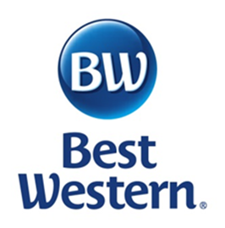
Welcome to the Best Western in Westminster, Maryland

We are centrally located to visit all the Civil War Heritage Areas; battlefield and sights of Antietam, Maryland Civil War Trails, Gettysburg, Monocacy, South Mountain, Harpers Ferry, Baltimore and Washington DC.

Our newly remodeled hotel offers a great mix of relaxation along with a business environment. The hotel is walking distance to local downtown Westminster cuisine and entertainment. The amenities and services include 101 beautifully appointed guestrooms, outdoor pool with ADA accessible lift, complimentary business center, complimentary hot breakfast, high speed internet, 24 hour business center and coffee bar, pet friendly, laundry machines and vending, Best Western Rewards Program, 37 inch Flat Screen TV, iron and ironing board, personal wake up calls, cable TV, phone with voice messaging, refrigerator, microwave, Grab and Go Breakfast, and Express Checkout.

By mentioning Heart of the Civil War, you are entitled to a Sunday to Thursday discounted rate of $89.99 per night, and a two day Friday and Saturday minimum discounted rate of $110.99 per night. We look forward to you enjoying our hotel while enjoying a bit of history!!

Wherever life takes you, Best Western is there

