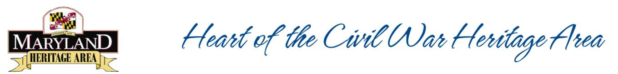
10 Tips for MHAA Project Grant Applications
- Make the case for the heritage tourism value of your project. Why are you looking to the Maryland Heritage Areas Authority as opposed to another funding source? Research and education projects can be huge generators of heritage tourism, but make the case explicitly.
- Be as specific as possible. Whether in your budget, timetable, or narrative, show that you have put detailed thought into the steps you’ll need to take to make your vision a reality. Provide page numbers when referencing the management plan, include price quotes for each item in your budget, and indicate every phase of your project.
- Solicit feedback on your draft before submitting. Involve your local grant reviewer, who can provide feedback on how to best strengthen your application. In addition, ask someone (either at your organization or outside of it) who is not very familiar with your project to review the application and catch any jargon.
- Be consistent. Make sure all elements appear in the narrative, timetable and budget.
- If creating a product, include a plan for maintenance. Whether you seek to create a digital product (website, app) or a physical one (interpretive marker, exhibit, renovated building), describe how you plan to maintain it without receiving additional funding.
- Show how state dollars will leverage investment. You are required to match the state grant dollar-for-dollar, but showing overmatch makes your project more appealing to reviewers.
- Don’t assume reviewers are familiar with your organization or project. Introduce the project as if the reviewers have no prior knowledge of your work.
- Think strategically about phases. If you are working on a very large, multi-year project, consider breaking it into multiple phases. You may increase your chances of receiving more funding if you apply for two $65,000 capital grants instead of one $100,000 grant. However, keep in mind that a second grant award is not guaranteed.
- While your project does not have to relate 100% to the Civil War, it should enhance the visitor experience in the Heritage Area. Our Management Plan is broad enough that many types of projects can support its goals and themes. However, you must make the case for why a heritage traveler would benefit from your project.
- Submit an Intent to Apply form even if you’re not certain you’ll apply for a grant in this cycle. The form is relatively simple to complete and you can change nearly all of the project details (budget, scope, timeline, description) between the ITA and grant application. The Heritage Areas program relies on ITAs to gauge the need for state funding and to assess the type of projects that are being considered statewide.

